|  |
| --- |
| **Software Version Description**  **(SVD)** |
| ***for the***  ***DLS Project***  ***BSP (Board support package)***  Prepared for:  Elbit Systems Ltd.  Prepared by:  Comm-IT ,20 Hamagshimim St. Petach Tikva 49348, ISRAEL |

**TABLE OF CONTENTS**

[1. SCOPE 3](#_Toc510965668)

[1.1 Identification 3](#_Toc510965669)

[1.2 System Overview 3](#_Toc510965670)

[1.3 Document Overview 4](#_Toc510965671)

[2. Referenced Documents 4](#_Toc510965672)

[2.1 Government Documents 4](#_Toc510965673)

[2.2 Project Documents 4](#_Toc510965674)

[2.3 Other Documents 4](#_Toc510965675)

[Version Description 5](#_Toc510965676)

[2.4 Inventory of Materials Released 5](#_Toc510965677)

[2.5 Inventory of Software Contents 5](#_Toc510965678)

[2.6 Changes Installed 5](#_Toc510965679)

[2.6.1 Class I Changes Installed 5](#_Toc510965680)

[2.6.2 Class II Changes Installed 5](#_Toc510965681)

[2.6.3 Changes Effects 5](#_Toc510965682)

[2.7 Adaptation data 5](#_Toc510965683)

[2.8 Related Documents 5](#_Toc510965684)

[2.9 Installation instructions 6](#_Toc510965685)

[2.9.1 Setup the host PC environment 6](#_Toc510965686)

[2.9.1.1 Open ghost on the host PC 6](#_Toc510965687)

[2.9.1.1.1 Import the station (ghost) file and starting it 6](#_Toc510965688)

[2.9.1.1.2 Login into the system 8](#_Toc510965689)

[2.9.1.2 Running environment bash script 8](#_Toc510965690)

[2.9.2 Build Android OS for target on-SOM eMMC memory 9](#_Toc510965691)

[2.9.3 Program the target with our prepared images 10](#_Toc510965692)

[2.10 Manually builds operations 10](#_Toc510965693)

[2.10.1 Manual build boot.img 10](#_Toc510965694)

[2.10.2 Manual build system u-boot 11](#_Toc510965695)

[2.10.3 Manual build system Kernel and modules 12](#_Toc510965696)

[3. Appendixes 13](#_Toc510965697)

[3.1 Appendix A: Web reference for documents 13](#_Toc510965698)

[3.2 Appendix B: Contents of CSCI files 13](#_Toc510965699)

# SCOPE

The Software Version Description (SVD) identifies and describes the released version of the DLS project: Bluetooth application.

## Identification

System name: DLS BSP.

System abbreviation: DLS

CSCI number: T.B.D

CSCI Name: T.B.D

CSCI abbreviation: T.B.D

CSCI version number:T.B.D

CSCI version issue date: 08.04.18

Software checksum: not required

## System Overview

The DLS (Digital Lethality system) system is hardware device that build to carry on light weapons. This system provides the warrior in combat zone to view data on the weapon sight such as: friendly zones, enemy zones and self-location. The product will present those data throw the natural view of the weapon without any interference on it. The product also has ability to communication nearby communications device using internal Bluetooth hardware and application which add the ability to transfer data in real time between warriors and commanders.

The BSP provide software application interface for running system Android operation system. It provides tools such as: VM OS (based on Linux Ubunto) and Linux libraries.

In the following figure, the DLS system is illustrated:

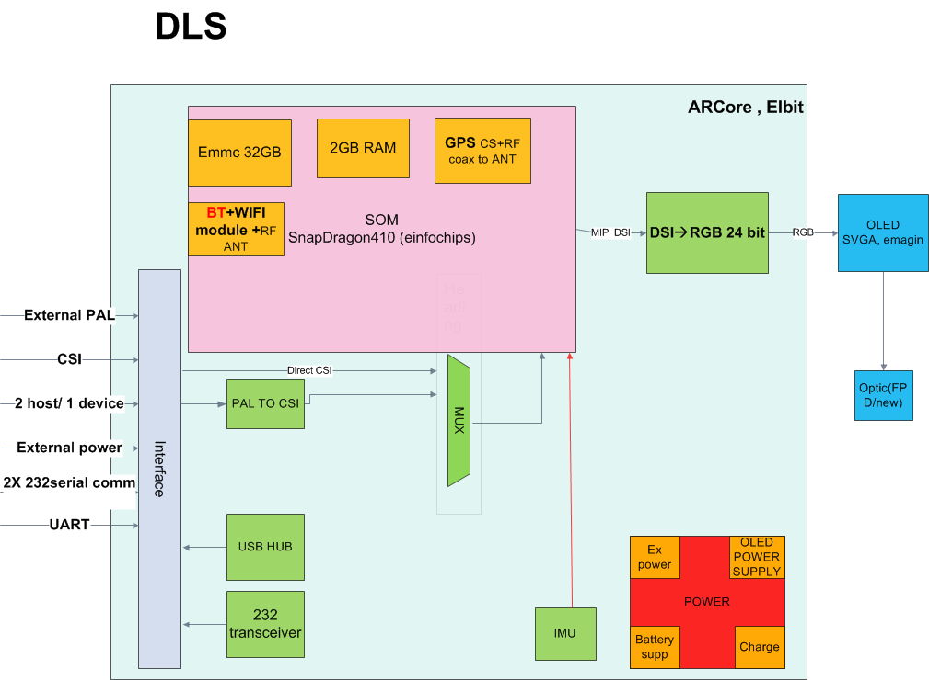

## Document Overview

The SVD identifies and describes the release procedure of the DLS BSP.

The documentation listed in paragraph 2.2 provides a detailed description of the software.

This SVD is structured as follows:

| Section | Contents |
| --- | --- |
| Section 1 | Scope of this document |
| Section 2 | All documents referenced by this SVD |
| Section 3 | Version description |
| Section 4 | Notes and Acronyms |
| Appendix A | Lists the files for this CSCI |

# Referenced Documents

## Government Documents

|  |  |  |  |
| --- | --- | --- | --- |
| **#** | **Title** | **Description** | **Date** |
|  |  | SOFTWARE VERSION DESCRIPTION (SVD) | 08/04/2018 |

## Project Documents

|  |  |  |  |  |
| --- | --- | --- | --- | --- |
| **#** | **Doc. ID** | **Title** | **Revision** | **Date** |
|  |  |  |  |  |
|  |  |  |  |  |
|  |  |  |  |  |

## Other Documents

|  |  |  |  |  |
| --- | --- | --- | --- | --- |
| **#** | **Doc. ID** | **Title** | **Revision** | **Date** |
|  |  |  |  |  |
|  |  |  |  |  |

# Version Description

## Inventory of Materials Released

None materials release

## Inventory of Software Contents

The release contains the following files:

|  |  |  |  |
| --- | --- | --- | --- |
| **File Name** | **Size** | **Date** | **Comment** |
| 03.04.18 | T.B.D | T.B.D |  |

The released version contains the CSCI’s files listed in appendix A.

## Changes Installed

## Class I Changes Installed

NA

## Class II Changes Installed

NA

## Changes Effects

NA

## Adaptation data

No adaptation is required

## Related Documents

The following table lists the associated documentation that makes up the new version, and the operation and support documents that are not a part of the delivered package, but required to operate, load, or regenerate the CSCI.

|  |  |  |  |  |
| --- | --- | --- | --- | --- |
| **#** | **Doc. ID** | **Title** | **Revision\*** | **Date** |
|  |  | DLS BSP SVD | 01 | 08.04.18 |
|  |  | DLS BSP PR | 01 | 08.04.18 |

\* The referenced documents' revision estate the applicable revisions relevant for this SW version on its release date.

CLASS II changes for these documents will not accompanied with new SVD revision.

Other SW versions relevant for the proper functionality of this CSCI version are listed in the following table:

|  |  |  |  |
| --- | --- | --- | --- |
| **#** | **SW Name** | **SVD/VDD Revision (in PLM)** | **Remarks** |
|  |  |  |  |
|  |  |  |  |

## Installation instructions

Motivation: In order to working with the DLS BSP environment we first need first to setup the PC host with VM Image that as provided. At the end of this document part we will able to build and run system image at our system target from the on-SOM eMMC.

Note: The following parts describing commands to run from the VM Image terminal.

## Setup the host PC environment

## Open ghost on the host PC

In order to run the virtual machine operation system you have to install the application: “Oracle VM VirtualBox manager” on windows PC (you can find it on the web at: <https://www.virtualbox.org/> , this instructions set test on version: 5.1.26 of this software).

1. Import the station (ghost) file and starting it:

## Import the station (ghost) file and starting it

On “Machine” tab -> click “add”. Then select the DLS.vbox file.

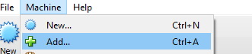

Please check that all of the settings of the machine are same as the following

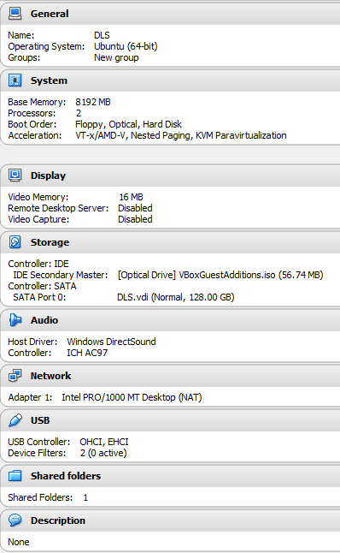

Then to start the machine click the green button “Start”

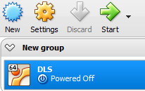

## Login into the system

At the login part please insert the password “dls” for login into the system.

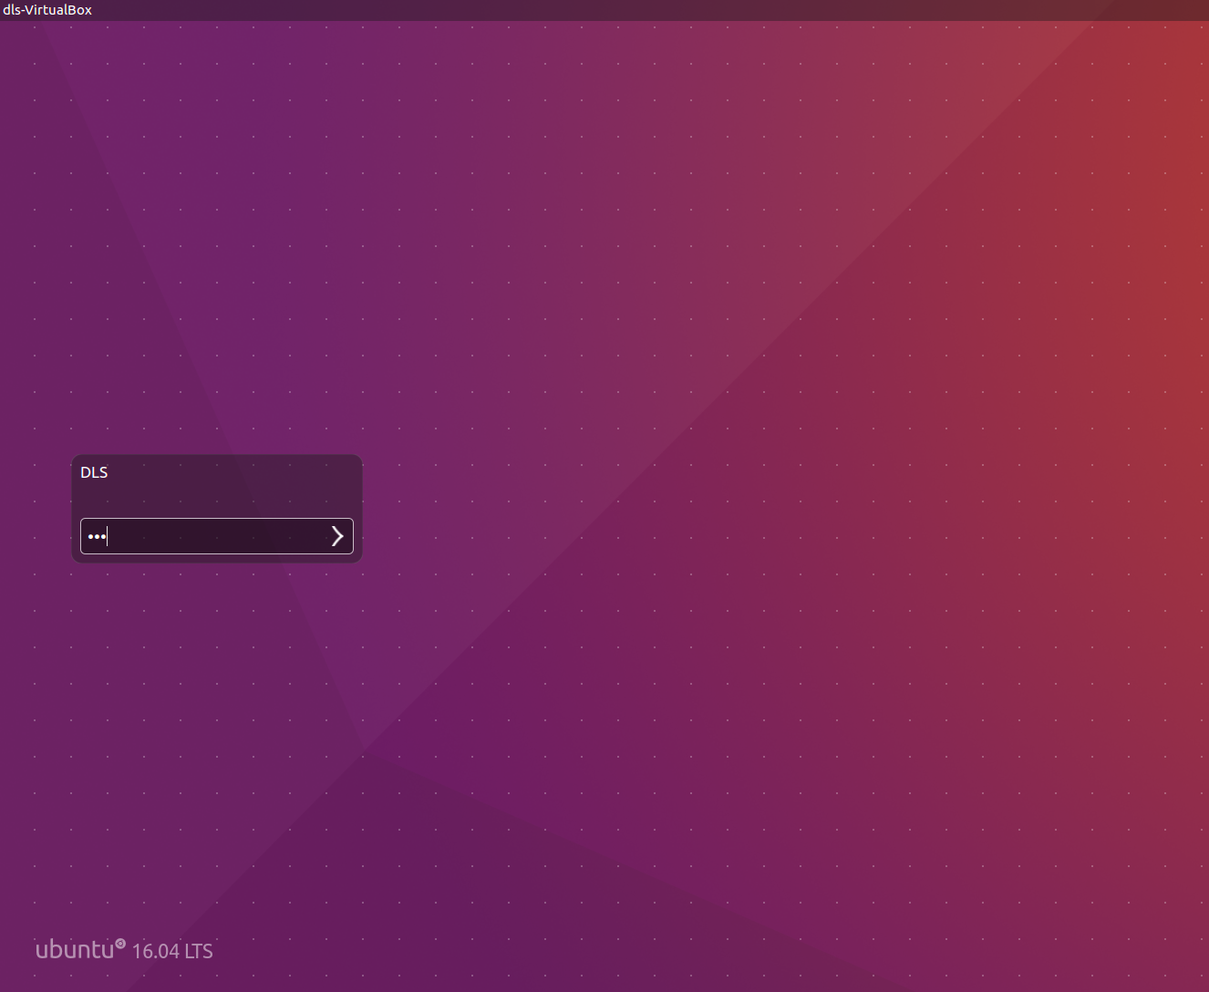

## Running environment bash script

1. Navigate to envsetup.sh shell script:

$ cd ~/var\_m\_601\_210/m\_601\_210\_build

1. Running the build script:

$ source build/envsetup.sh

$ lunch var\_mx6-eng

This part will setup the host environment tool chains and required path for build the next steps.

After running the above command we will get the following window (if everything is O.K):

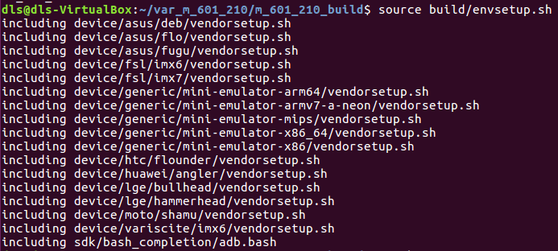

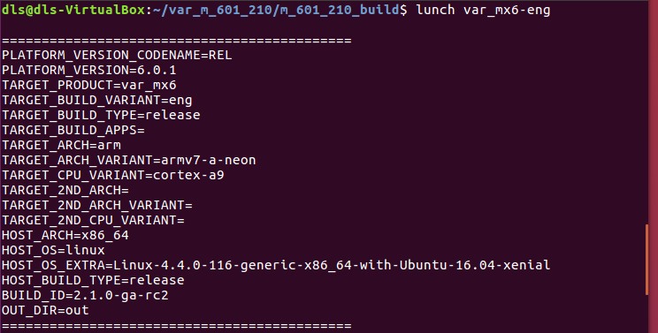

## Build Android OS for target on-SOM eMMC memory

$ make -j4 BUILD\_TARGET\_DEVICE=emmc 2>&1 | tee build1-1.log

This command will make the necessary files for build the next steps.

If everything goes O.K we will:

1. Get the following message in terminal:

#### make completed successfully (time take to finish [~ 22 Min]) ####

1. Get operation log: Build1-1.log

At the path: var\_m\_601\_210/m\_601\_210\_build

1. We will get the following files updated

At the path: var\_m\_601\_210/m\_601\_210\_build/out/target/product/var\_mx6

1. "Boot-image": boot-imx6q-var-dart.img [File size: 9,737,512 bytes].
2. "Recovery-image": recovery-imx6q-var-dart.img [File size: 10,487,084 bytes].
3. "System (Android OS file) image": system.img [File size: 387,192,932].

## Program the target with our prepared images

1. Insert the target to program mode:

$ adb reboot bootloader

1. Program Boot-Image:

$ sudo fastboot flash boot out/target/product/var\_mx6/boot-imx6q-var-dart.img

1. Program Recovery-Image:

$ sudo fastboot flash recovery out/target/product/var\_mx6/recovery-imx6q-var-dart.img

1. Program Recovery-Image:

$ sudo fastboot flash recovery out/target/product/var\_mx6/recovery-imx6q-var-dart.img

1. Program System-Image:

$ sudo fastboot flash system out/target/product/var\_mx6/system.img

1. Reboot the target:

$ sudo fastboot reboot

## Manually builds operations

The above described builds operations can be done individually if needed for faster build times (build only the image that is necessary).

## Manual build boot.img

Navigate to project build folder:

$ cd ~/var\_m\_601\_210/m\_601\_210\_build

Run build script:

$ source build/envsetup.sh

$ lunch var\_mx6-eng

$ make bootimage

If everything goes O.K we will get the following images:

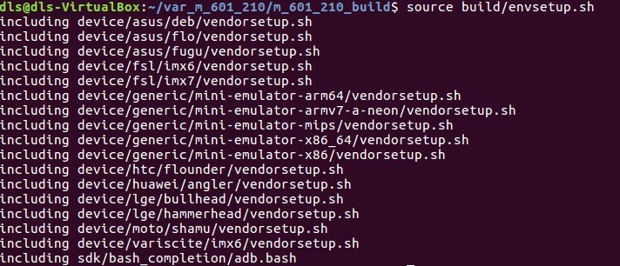

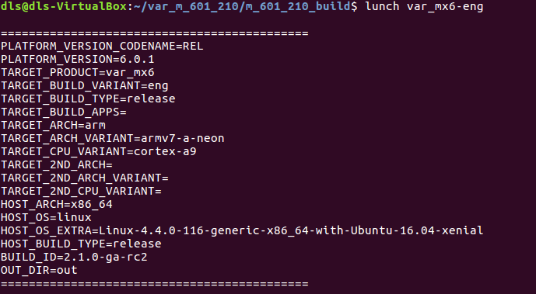



And the file “boot-som-mx6q-r.img” in /var\_m\_601\_210/m\_601\_210\_build/out/target/product/var\_mx6 will be update.

## Manual build system u-boot

* 1. Setup the host tool-chain

$ export ARCH=arm

$ export CROSS\_COMPILE=.../variscite/var\_m\_601\_210/m\_601\_210\_build/prebuilts/gcc/linux-x86/arm/arm-eabi-4.8/bin/arm-eabi-

* 1. Manual build Bootloader

Change directory to U-Boot

$ cd ~/var\_m\_601\_210/m\_601\_210\_build/bootable/bootloader/uboot-imx

Clean build tree

$ make mrproper

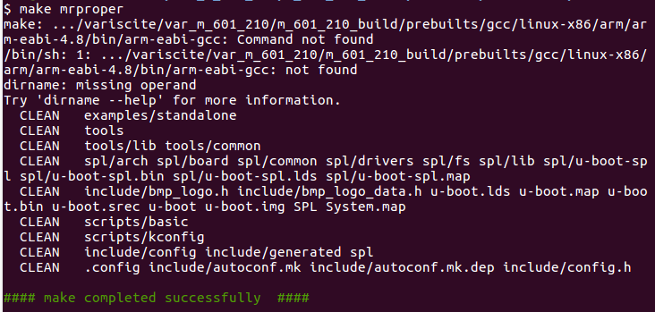

Build u-boot for target SD card

$ make mx6var\_som\_sd\_android\_defconfig

$ make -j4

## Manual build system Kernel and modules

1. Manual build Android Linux Kernel and modules

Change directory to system kernel

$ cd ~/var\_m\_601\_210/m\_601\_210\_build/kernel\_imx

Clean directory

$ make distclean

Make build files

$ make imx\_v7\_var\_android\_defconfig

$ make -j4 uImage LOADADDR=0x10008000

$ make -j4 modules

## 3. Appendixes

## 3.1 Appendix A: Web reference for documents

<variwiki.com/index.php?title=VAR-SOM-MX6_Android_M6.0.1_2.1.0>

## 3.2 Appendix B: Contents of CSCI files

List of files for the DLS BSP can be found at the file “DLS\_BSP\_1\_01\_LIST\_FILES.txt”